Insert Name of Facility

Health Care Facility

Emergency Plan

Insert Date Template is Completed/Revised

Supersedes Previous Version

This plan covers license year Insert Year

Insert License Number

Table of Contents

Introductory Material 7

Approval and Implementation 7

Facility Profile 8

Facility Profile 2 9

Record of Changes 10

Record of Distribution 11

Purpose, Scope, Situation Overview, and Assumptions 12

Executive Summary 12

Purpose 12

Scope 12

Situation Overview 13

Hazard Analysis Summary 13

Capability Estimates 14

Mitigation Overview 14

Planning Assumptions 15

Concept of Operations 16

Incident Management 16

Plan Activation 17

Organization and Assignment of Responsibilities 18

Direction, Control, and Coordination 19

Command Structure 19

Orders of Succession 23

Delegation of Authority 24

Local Emergency Operations Center Coordination 25

Public Health Coordination 27

Regional Healthcare Coalition Coordination 28

Information Collection, Analysis, and Dissemination 29

Communications 31

Patient/Resident Management in an Emergency 32

Patient Scheduling, Triage/Assessment, Treatment, Transfer, and Discharge 32

Vulnerable Populations 32

Management of Behavioral Health Patients 32

Behavioral Health Services to Patients 32

Patient/Resident Tracking 33

Evacuation or Shelter in Place 34

Transportation Resources for Evacuation 34

Evacuation Locations 34

Medical Documentation 35

Shelter in Place 35

Alternate Care Sites 35

Utilities 36

Power 36

Generator Failures 36

Water 37

Water for Drinking, Cooking, and Sanitation 37

Water Rationing 37

Medical Gas/Vacuum Systems 38

Vacuum System 38

Maintenance Activities 39

Recovery 40

Initiation and Recovery 40

Recovery Protocol 40

Recovery protocols 40

Restoration of Services 40

Utility Restoration 41

Staff/Patient Re-Entry 41

Staff Debriefing 41

After-Action Report/Improvement Plan 41

Administration, Finance, and Logistics 42

Logistics 42

Resources and Assets 42

Management of Staff 44

Assignment of Staff 44

Managing Staff Support Needs 44

Volunteer Management 45

Plan Development and Maintenance 46

Plan Review 46

Training Program 46

Exercise Program 46

Finance 47

Authorities and References 48

Glossary 50

Acronyms 54

The Missouri State Emergency Management Agency, in collaboration with the Missouri Department of Health and Senior Services, has developed an EMERGENCY OPERATIONS PLAN TEMPLATE for Missouri Healthcare Facilities. This document is not all inclusive and should be used as a guide. It is not intended to supersede or substitute for compliance with Missouri Department of Health Division of Regulation and Licensure licensing regulations or the requirements of the Centers for Medicare and Medicaid Services or other accreditation requirements.

Each facility should adopt this template to their unique needs and customize it accordingly. The FEMA six step planning process below is suggested for the adaptation and implementation of this template to meet a facility or organization’s emergency planning needs. The Department does not guarantee that a facility using this template will be in compliance with Federal or State regulations or that all issues are addressed. Furthermore, staff must be trained in the use of the plan, yearly continuing education must be conducted, and the plan must be tested regularly and refined.

**The “red” text throughout the document indicates items for the facility to fill out with the appropriate information.**

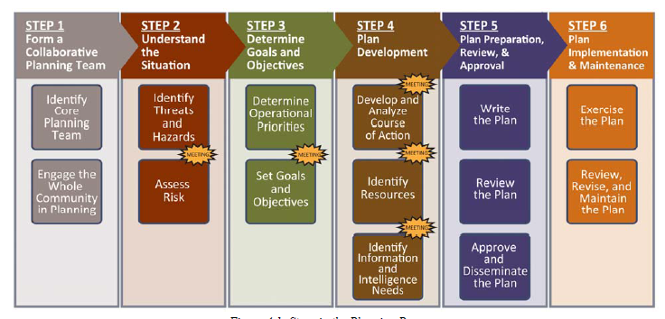

**Figure 1: FEMA Six Step Planning Process guide**

The community should be an integral part of any facility/organization planning process. They are an integral resource for validating assumptions about needs, capabilities, and response. The local emergency management directors and their local emergency planning committees can be your best source for starting your emergency plan and forming your community involvement. Regional health care coalitions will also be valuable in focusing your health related emergency response.

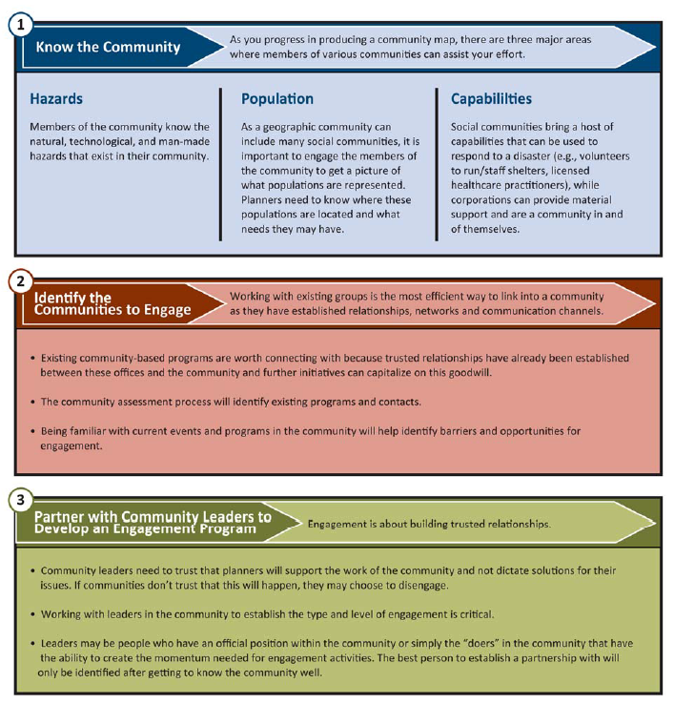

**Figure 2: FEMA Community Engagement in Planning**

Additional information on the planning process can be found at:

<https://www.fema.gov/media-library-data/20130726-1828-25045-0014/cpg_101_comprehensive_preparedness_guide_developing_and_maintaining_emergency_operations_plans_2010.pdf>

# Introductory Material

## Approval and Implementation

This Emergency Operations Plan (EOP) was prepared by <insert facility name> to develop, implement, and maintain a viable all hazards response capability and to establish a comprehensive approach to providing consistent, effective, and efficient coordination across a spectrum of disaster response activities.

This plan addresses emergency response activities at the Insert Location of Facility Campus.

The List Position shall be responsible for plan oversight and coordination with applicable stakeholders. This EOP is based on the “all-hazards” concept and plans for natural and man-made disasters and incidents. The plan is flexible in that part of the plan or the entire plan may be activated based on the specific emergency and decision by facility administration.

**This emergency plan has been completed and approved through a collaborative process of stakeholders. The** Signatory Authority **has reviewed and approved of this plan. This version of the Plan supersedes all previous editions of the Plan.**

**______________________________________ _________________**

Name, Title Date

**______________________________________ _________________**

Name, Title Date

Annual Review

This document will be reviewed *annually* and revised to reflect improvements identified in exercises, real life events, and changing guidance.

Reviewed by:

**______________________________________ _________________**

Name, Title Date of Review

## Facility Profile

The Facility Profile provides a brief description of your facility, the residents you serve and their specific vulnerabilities, and your facility’s current level of readiness. The second profile can be used by facilities possessing backup generators.

|  |  |  |  |
| --- | --- | --- | --- |
| **Facility Name:** | Facility Name | | |
| **Address:** | Address Line 1 | | |
|  | Address Line 2 | | |
| **County:** | County | | |
| **Phone:** | Phone Number | **Fax:** | Fax Number. |
| **Emergency Phone:** | Emergency Phone Number | | |
| **Email Address:** | Email Address | | |

|  |  |  |  |
| --- | --- | --- | --- |
| **Owner/Corporation:** | Owner/Corporation | | |
| **Address:** | Address Line 1 | | |
|  | Address Line 2 | | |
| **Phone:** | PhoneNumber | **Secondary Phone:** | Secondary Phone |
| **Emergency Phone:** | Emergency Phone Number. | | |

|  |  |  |  |
| --- | --- | --- | --- |
| **Facility Administrator:** | Facility Administrator | | |
| **Address:** | Address Line 1 | | |
|  | Address Line 2 | | |
| **Phone:** | PhoneNumber | **Secondary Phone:** | Secondary Phone | |
| **Emergency Phone:** | Emergency Phone Number | | |

|  |  |  |  |  |
| --- | --- | --- | --- | --- |
| **Emergency Plan Coordinator:** | Emergency Plan Coordinator | | | |
| **Address:** | Address Line 1 | | | |
|  | Address Line 2 | | | |
| **Phone:** | PhoneNumber | **Secondary Phone:** | | Second Phone |
| **Emergency Phone:** | Emergency Phone Number | | | |
|  |  | | | |
| **Licensed Facility Bed Capacity** | | | Bed Capacity | |
| **Average Daily Census:** | | | Average Daily Census | |
| **Specialty Services or Units:** | | | Specialty Services or Units | |

## Facility Profile 2

|  |  |  |  |  |  |
| --- | --- | --- | --- | --- | --- |
| Facility Name: | Facility Name | | | | |
| Facility Type: | Facility Type | | | | |
| Mailing Address: | Mailing Address | | | | |
| Physical Address (if different from above) | | Physical Address (if different from mailing address) | | | |
| Phone: | Phone Number | | Fax: | Fax Number | |
| Primary contact person able to discuss emergency plans: | | | | | |
| Name: | Primary Contact Name | | | | |
| Phone: | Phone Number | | Email: | Email Address | |
| Backup contact person able to discuss emergency plans: | | | | | |
| Name: | Back Up Contact Name | | | | |
| Phone: | Phone Number | | Email: | Email Address | |
| Does the facility care for OR have the ability to care for special populations, for example, residents on ventilators, dialysis, with dementia, mobility impairments, etc.? | | | | | Yes  No |
| If YES, please list the special populations: | | | Specific Populations | | |
| Average Daily Census | | | Average Daily Census | | |
| Licensed Capacity: *Please indicate the capacity of your facility based upon licensing.* | | | | | Capacity |
| Surge Capacity: *Please indicate the maximum number of residents which could be accommodated by your facility with appropriate waivers or flexes.* | | | | | Capacity |
| Number of staff (full time equivalents): | | | Number of Staff | | |
| Does your facility have a back-up generator? | | | Yes  No | | |
| If NO, is your facility wired to receive a back-up generator? | | | Yes  No | | |

## Record of Changes

This is a continuing record of all changes to the EOP.

|  |  |  |  |
| --- | --- | --- | --- |
| **Change Number** | **Date of Change** | **Description of Change** | **Initials** |
| # | Date | Description of Change | Initials |
| # | Date | Description of Change | Initials |
| # | Date | Description of Change | Initials |
| # | Date | Description of Change | Initials |
| # | Date | Description of Change | Initials |
| # | Date | Description of Change | Initials |
| # | Date | Description of Change | Initials |
| # | Date | Description of Change | Initials |
| # | Date | Description of Change | Initials |
| # | Date | Description of Change | Initials |
| # | Date | Description of Change | Initials |
| # | Date | Description of Change | Initials |
| # | Date | Description of Change | Initials |
| # | Date | Description of Change | Initials |
| # | Date | Description of Change | Initials |
| # | Date | Description of Change | Initials |
| # | Date | Description of Change | Initials |
| # | Date | Description of Change | Initials |
| # | Date | Description of Change | Initials |
| # | Date | Description of Change | Initials |
| # | Date | Description of Change | Initials |
| # | Date | Description of Change | Initials |

## Record of Distribution

This plan has been provided to the following personnel and/or agencies.

|  |  |  |  |
| --- | --- | --- | --- |
| **Recipient Name** | **Department/Agency** | **Date Distributed** | **Initials** |
| Recipient Name | Department/Agency | Date | Initials |
| Recipient Name | Department/Agency | Date | Initials |
| Recipient Name | Department/Agency | Date | Initials |
| Recipient Name | Department/Agency | Date | Initials |
| Recipient Name | Department/Agency | Date | Initials |
| Recipient Name | Department/Agency | Date | Initials |
| Recipient Name | Department/Agency | Date | Initials |
| Recipient Name | Department/Agency | Date | Initials |
| Recipient Name | Department/Agency | Date | Initials |
| Recipient Name | Department/Agency | Date | Initials |
| Recipient Name | Department/Agency | Date | Initials |
| Recipient Name | Department/Agency | Date | Initials |
| Recipient Name | Department/Agency | Date | Initials |
| Recipient Name | Department/Agency | Date | Initials |
| Recipient Name | Department/Agency | Date | Initials |
| Recipient Name | Department/Agency | Date | Initials |
| Recipient Name | Department/Agency | Date | Initials |
| Recipient Name | Department/Agency | Date | Initials |
| Recipient Name | Department/Agency | Date | Initials |
| Recipient Name | Department/Agency | Date | Initials |
| Recipient Name | Department/Agency | Date | Initials |
| Recipient Name | Department/Agency | Date | Initials |

# Purpose, Scope, Situation Overview, and Assumptions

## Executive Summary

This plan is the foundation for the all hazards emergency preparedness program forInsert Name of Facility**.** The Emergency Preparedness Program shall be comprised of four basic elements: 1) An all-hazards risk assessment and emergency plan; 2) A communications plan; 3) supporting policies and procedures; and 4) a training and exercise program. The Emergency Plan shall be comprised of an Emergency Operations Plan (EOP) and supporting Annexes which will include hazard specific information, response checklists, and worksheets for response for hazards that have been identified in the facility’s Hazard Vulnerability Assessment (HVA).

The EOP is an all-hazards plan that outlines policies and procedures for preparing for, responding to, and recovering from possible hazards faced by the organization. Coordination of planning and response with other healthcare organizations, public health, and local emergency management will be included. The plan also addresses proper plan maintenance, communications, resource and asset management, patient care, continuity of operations, management of staff, evacuation, and contingency planning for utilities failure.

The plan will undergo an annual review process to ensure any plan deficiencies are identified and addressed. An improvement plan will be instituted and maintained to ensure lessons learned and action items identified from exercises and real events are properly addressed and documented.

All response activities will follow the National Incident Management System (NIMS) guidelines. In addition, the agency will follow the Incident Command System organizational structure in response to emergency events and in exercises. In the event of a communitywide emergency, the agency’s incident command structure will be integrated into and be consistent with the community command structure. Staff should receive ICS training appropriate to their level of response and assigned roles and responsibilities to ensure they are prepared to meet the needs of patients in an emergency.

## Purpose

The purpose of this emergency plan is to provide guidance to Insert Name of Facility on how to respond to and recover from an emergency event that exceeds the day to day capability of the organization to manage with normal operations with the purpose of protecting the lives and property of patients/residents, staff, and visitors. This type of an event will be called an emergency incident for purposes of this plan.

## Scope

The Emergency Operations Plan (EOP) is designed to guide planning and response to a variety of hazards that could threaten the environment of theInsert Facility Type or the safety of patients, staff and visitors, or adversely impact the ability of the Insert Facility Type to provide healthcare services to the community. The plan is also designed to meet state and federal planning requirements, though the ultimate responsibility for meeting those requirements rests with the facility. This plan covers Insert Facility Name and Any Other Included Buildings

Authority for activating the plan will rest with the Insert Position Title**.** Activation of the plan will be conducted in conjunction with agency command staff as well as local emergency management and public health personnel, when appropriate.

The Emergency Plan consists of the Basic Plan or Emergency Operations Plan (EOP) and supporting annexes. The Emergency Operations Plan is the all hazards response overview, concept of operations, and organizational structure. The supporting annexes provide more detail on the initial response to priority hazards, threats, and events and operational planning.

## Situation Overview

### Hazard Analysis Summary

A hazard vulnerability analysis (HVA) is conducted annually by Insert Name of Entity and can be found in Appendix XX. This assessment provides expected likelihood and impacts from various hazards. This analysis of likely hazards aids the facility in prioritization of emergency preparedness activities and response planning. This assessment has been shared at the local and regional levels with healthcare and emergency management partners.

The top identified hazards for this facility are found below**.** These top five hazards have been shared at the community and regional level for partner awareness.

|  |  |
| --- | --- |
| Rank | Hazard |
| 1 | Hazard |
| 2 | Hazard |
| 3 | Hazard |
| 4 | Hazard |
| 5 | Hazard |

### Capability Estimates

A Capability Estimate is an assessment of a facility/organizations ability to take a course of action and to determine if the course of action is reasonable and supportable. It estimates the capabilities and resource types needed to complete a set of courses of action.

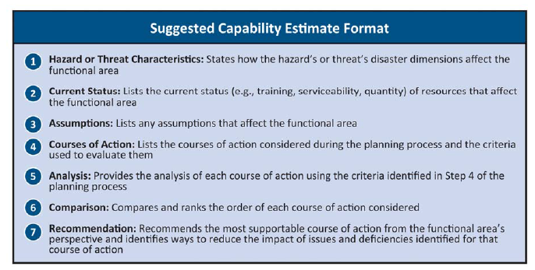

Capability Estimates are included in functional and hazard specific annexes.

### Mitigation Overview

Mitigation efforts work to lessen the impact of a hazard that the facility/organization is likely to face. Mitigation planning and actions to reduce long term vulnerability may include the establishment of mitigation goals and objectives, determining mitigation actions which may include activities such as land use planning, structural projects, natural systems protection, education, and preparedness sand response actions. These actions should be prioritized according to a cost-benefit analysis and the ability to meet the stated mitigation objectives.

The table below lists potential Mitigation Activities. See each hazard specific annex for more detailed mitigation analysis.

|  |  |  |  |  |  |
| --- | --- | --- | --- | --- | --- |
| **Identified Hazard** | **Mitigation Goal** | **Objectives** | **Actions** | **Implementation Documents** | **Assigned To** |
| Hazard | Goal | Objectives | Actions | Documents | Assigned To |
| Hazard | Goal | Objectives | Actions | Documents | Assigned To |
| Hazard | Goal | Objectives | Actions | Documents | Assigned To |
| Hazard | Goal | Objectives | Actions | Documents | Assigned To |

# Planning Assumptions

The following set of assumptions governs the parameters by which this plan was developed.

* Emergencies can happen at any time.
* Emergencies will differ in type, size, scope, and duration.
* The facility is ultimately responsible for the safety of its patients and staff. External resources may or may not be available in emergency situations. The facility must understand how they are incorporated into local, regional, and state plans and coordination efforts to participate in available resource request processes.
* Local, state, and federal departments and other healthcare facilities may provide assistance necessary to protect lives and property, however, these resources may not be available and the facility should plan to manage the incident themselves, at least for a period of time.
* While this plan outlines actions that should be taken during emergency situations, staff will need to adapt their actions as appropriate for the specifics of the situation.
* No emergency plan can cover all possible contingencies, this plan should be used as a guide and a planning tool to prepare staff and the Insert Facility Type for the most likely hazards that could occur as based on the Hazard Vulnerability Analysis.
* The plan must be implemented in a flexible manner to be successful.
* All staff will be familiar with the plan and their expected responsibilities.
* Staff will execute their responsibilities as outlined in this plan during the emergency event.
* Proper execution of this EOP will save lives and reduce damage from the emergency event.

# Concept of Operations

## Incident Management

Incident management activities are divided into four phases: mitigation, preparedness, response, and recovery. These four phases are described below:

Mitigation: Mitigation activities focus in the impact of a hazard and look at the structural and non-structural approaches to eliminate or limit a hazard’s presence, people’s exposure, or interactions with people, property, and the environment. For healthcare operations, this may include installing generators for backup power, installing wind resistant windows, and raising electrical panels to protect them from possible flood damage. Insert Facility’s Strategies for Mitigation

Preparedness: Preparedness activities develop the response capabilities that are needed in the event an emergency occurs. These activities may include developing emergency operations plans and procedures, conducting training for personnel in those procedures, and conducting exercises with staff to ensure they are capable of implementing response procedures when necessary.Insert Facility’s Strategies for Preparedness

Response: Response includes those actions that are taken when a disruption or emergency occurs. It encompasses the activities that address the short-term, direct effects of an incident. Response activities in the healthcare setting can include activating emergency plans and triaging and treating patients who have been affected by an incident. Insert Facility’s Strategies for Response

Recovery: Recovery focuses on restoring operations to a normal or improved state of affairs by both short term and long term efforts. It occurs after the immediate stabilization of the incident in a continuum until long term recovery is achieved. Examples of recovery activities include: the restoration of interrupted utility services, non-vital functions, replacement of damaged equipment, facility repairs, organized return of patients into the facility, and reconstitution of patient records and other vital information systems. Another key consideration in the recovery and response phases of an incident is the tracking of staff hours, expenses, and damages incurred as a result of the emergency. Detailed records will need to be maintained throughout an emergency to document expenses and damages for possible reimbursement or to properly file insurance claims. Insert Facility’s Strategies for Recovery

## Plan Activation

The Emergency Operations Plan will be activated in response to internal or external threats to the facility. Internal threats could include fire, bomb threat, and loss of power /other utility or other incidents that threaten the well-being of patients, staff, and/or the facility itself. External threats include incidents that may not affect the facility directly but have the potential to overwhelm Insert Facility Type resources or put the Insert Facility Type on alert.

**Persons Responsible for Plan Activation**

Once a threat has been confirmed, the employee obtaining the information must notify Insert Process (emergency number, their supervisor, House supervisor) immediately. If the employee cannot contact 1st Contact Method they must immediately contact the Insert Position Title directly.

The Supervisor should in turn contact the Insert Position Title**.** The Insert Position Title will assess the situation and initiate the plan if necessary.

The following staffed positions have the authority to activate the Emergency Operations Plan:

**Position Responsible for Emergency Operations Plan Activation**

|  |  |
| --- | --- |
| Position/Title | Contact Number |
| Primary: Position/Title | Contact Number |
| Backup 1: Position/Title | Contact Number |
| Backup 2: Position/Title | Contact Number |

**Alerting Staff (On and Off Duty)**

To notify staff that the Emergency Operations Plan has been activated, those within the facility will be contacted first through the Insert Internal Communication System (i.e. overhead paging system, radio).

Staff away from the facility at the time of activation will be contacted Insert External Communication System (i.e. phone tree, radio, media). The individuals responsible for contacting staff include the Insert Position Title (i.e. dispatcher, supervisor).

**Alerting Response Partners**

The facility works closely with several external partners **(See Appendix** XX**: Communications Plan)**. The Insert Position Title will be the individual responsible for contacting these external agencies to notify them that the Emergency Operations Plan has been activated.

# Organization and Assignment of Responsibilities

During an event, specific roles and responsibilities will be assigned to individual positions/titles as well as facility departments.

**Essential Services**

The table below identifies the departmental roles and responsibilities during plan activation**.**

**Roles and Responsibilities**

|  |  |  |  |
| --- | --- | --- | --- |
| Essential Services | Roles and Responsibilities | Point of Contact by Position | Secondary Point of Contact |
| Administration | Roles/Responsibility | POC by Position | Secondary POC |
| Dietary | Roles/Responsibility | POC by Position | Secondary POC |
| Housekeeping | Roles/Responsibility | POC by Position | Secondary POC |
| Maintenance | Roles/Responsibility | POC by Position | Secondary POC |
| Nursing | Roles/Responsibility | POC by Position | Secondary POC |
| Pharmacy | Roles/Responsibility | POC by Position | Secondary POC |
| Safety & Security | Roles/Responsibility | POC by Position | Secondary POC |
| (Add additional essential services if needed) | Roles/Responsibility | POC by Position | Secondary POC |

**Positions**

Identifying and assigning personnel in the Incident Command System (ICS) depends a great deal on the size and complexity of the incident. The HICS is designed to be flexible enough so that the number of staff needed to respond to an incident can be easily expanded or contracted. HICS Form 203 is used to document and assign staff to HICS specific positions. See ICS forms in Appendix XX.

# Direction, Control, and Coordination

The facility will coordinate emergency operations from the facility command center. This command center will be located Insert Command Center Location with the backup location at Insert Backup Command Center Location. See Appendix XX for contact information. The Insert Position will assume initial facility Incident Commander until HICS can be implemented.

## Command Structure

Command will be organized according to the Incident Command System (ICS). The chart below illustrates the structure of response activities under the HICS. The chart shows the chain of command and the span of control under each level of management. It also illustrates the flexibility of HICS to expand or contract response activities based on the type and size of the event and staff size. Positions should be appointed as needed per the size and scope of the incident. The Incident Commander shall assume responsibility for all event actions unless other positions are appointed as consistent with ICS principles.

**Example: HICS Organizational Chart**



**HICS Positions with Possible Hospital Staffing Position Candidates**

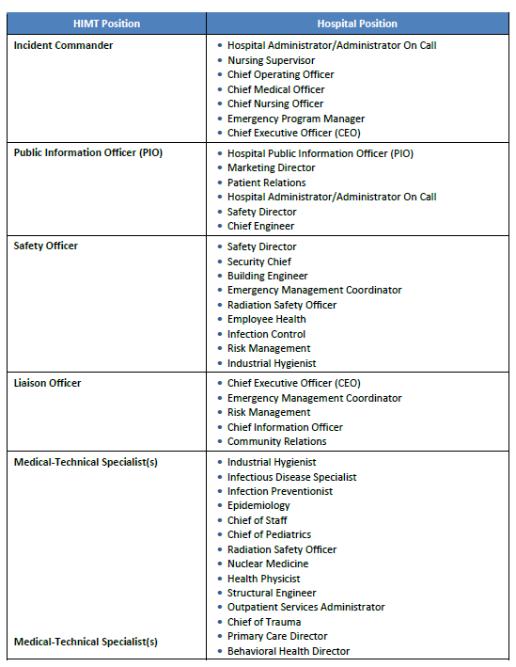

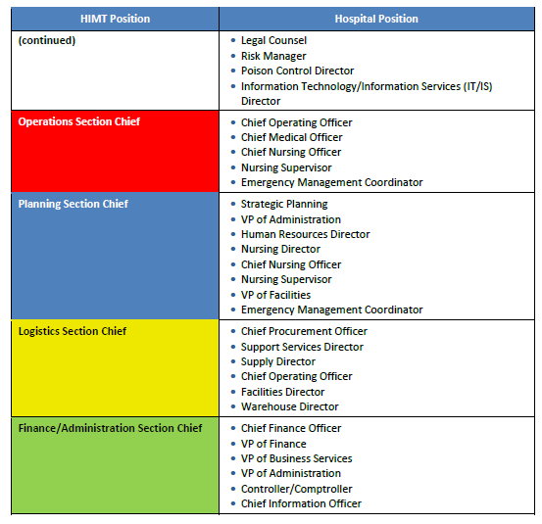

### Orders of Succession

Orders of succession ensure leadership is maintained throughout the facility during an event when key personnel are unavailable. Succession will follow facility policies for the key facility personnel and leadership.

**Key HICS Position Assignments and Orders of Succession**

| **Command and Control** | **Primary** | **Successor 1** | **Successor 2** |
| --- | --- | --- | --- |
| **Shift 1** | | | |
| Insert Facility Type Representative | Primary | Successor 1 | Successor 2 |
| Incident Commander | Primary | Successor 1 | Successor 2 |
| Public Information Officer | Primary | Successor 1 | Successor 2 |
| Safety Officer | Primary | Successor 1 | Successor 2 |
| Liaison | Primary | Successor 1 | Successor 2 |
| Operations Section Chief | Primary | Successor 1 | Successor 2 |
| Planning Section Chief | Primary | Successor 1 | Successor 2 |
| Logistics Section Chief | Primary | Successor 1 | Successor 2 |
| Finance/Administration Section Chief | Primary | Successor 1 | Successor 2 |
| **Shift 2** | | | |
| Insert Facility Type Representative | Primary | Successor 1 | Successor 2 |
| Incident Commander | Primary | Successor 1 | Successor 2 |
| Public Information Officer | Primary | Successor 1 | Successor 2 |
| Safety Officer | Primary | Successor 1 | Successor 2 |
| Liaison | Primary | Successor 1 | Successor 2 |
| Operations Section Chief | Primary | Successor 1 | Successor 2 |
| Planning Section Chief | Primary | Successor 1 | Successor 2 |
| Logistics Section Chief | Primary | Successor 1 | Successor 2 |
| Finance/Administration Section Chief | Primary | Successor 1 | Successor 2 |

### Delegation of Authority

Delegations of authority specify who is authorized to make decisions or act on behalf of facility leadership and personnel if they are away or unavailable during an emergency. Delegation of authority planning involves the following:

* Identifying which authorities can and should be delegated
* Describing the circumstances under which the delegation would be exercised and including when it would become effective and terminate
* Identifying limitations of the delegation
* Documenting to whom authority should be delegated
* Ensuring designees are trained to perform the emergency duties

**Emergency Authority Delegation**

| **Authority** | **Type of Authority** | **Position Holding Authority** | **Triggering Conditions** |
| --- | --- | --- | --- |
| Activate Facility Command Center | Emergency Authority | Insert Position w/Authority (i.e. House Supervisor) | Insert Triggers |
| Activate Emergency Annexes and the Emergency Operations Plan | Emergency Authority | Insert Position w/Authority (i.e. House Supervisor) | Insert Triggers |
| Close facility | Emergency Authority | Insert Position w/Authority (i.e. Senior Leadership) | Insert Triggers (i.e. when conditions make coming to or remaining in the facility unsafe). |
| Represent facility when engaging Govt. Officials | Administrative Authority | Insert Position w/Authority (i.e. Senior Leadership) | Insert Triggers (i.e. when the pre-identified is not available. |
| Activate facility memorandum of understanding/mutual aid agreements | Administrative Authority | Insert Position w/Authority (i.e. Senior Leadership) | Insert Triggers |
| Add additional authorities as needed |  |  |  |

## Local Emergency Operations Center Coordination

This organization will coordinate fully with the Insert Name of Local Emergency Management Agency, follow the prescribed Incident Command System, and integrate fully with community agencies in activation for a disaster event or during exercises. Insert Agency/Position (i.e. Local Public Health/ESF 8) is the healthcare agency contact at the local Emergency Operations Center.

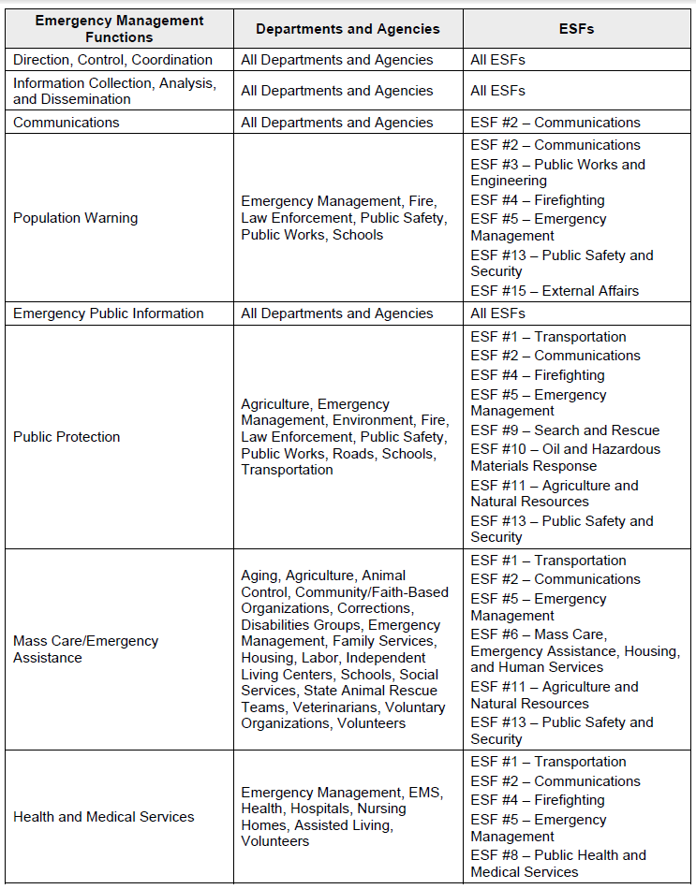

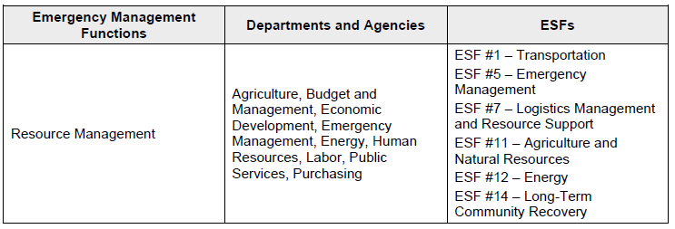

The Insert Facility Type will provide the following information: Insert Facility Type occupancies, Insert Facility Type needs, and a list of essential services the Insert Facility Type can provide. The facility participates in Insert Any Regional/County Coalition/Local Emergency Planning Committee, as appropriate Figure 3 illustrates the interaction of the various positions in the facility command center with the local and regional command center structures.

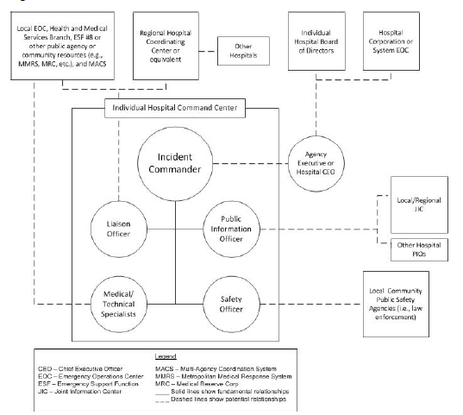

**Figure 3: Facility Command Center External Communication**

## Public Health Coordination

The Insert Position Title will coordinate planning and response activities with local public health. Activities may include:

* Following Missouri disease reporting requirements at: <http://health.mo.gov/living/healthcondiseases/communicable/communicabledisease/pdf/reportablediseaselist1.pdf>
* In the event the Emergency Operation Plan is activated by the facility, the facility shall InsertAction Required.
* Providing regular updates to the Statewide Medical Resource Tracking Tool (EMResource) as required (See Appendix XX).
* Participating in public health planning initiatives.
* Receiving guidance and health alerts through the Health Alert Network.
* Participating in any after-action planning as requested from public health officials.

Describe/Outline how the facility will coordinate planning and response activities with public health.

## Regional Healthcare Coalition Coordination

The facility is aDescribe Membership Type (i.e. member, affiliate, etc.)of theInsert Regional Healthcare Coalition Nameand participates in regular planning meetings, quarterly exercises, and incident activations. The regional healthcare coalition serves as a conduit for communication and coordination of the health and medical sectors during facility, community, regional, or statewide emergency activations.

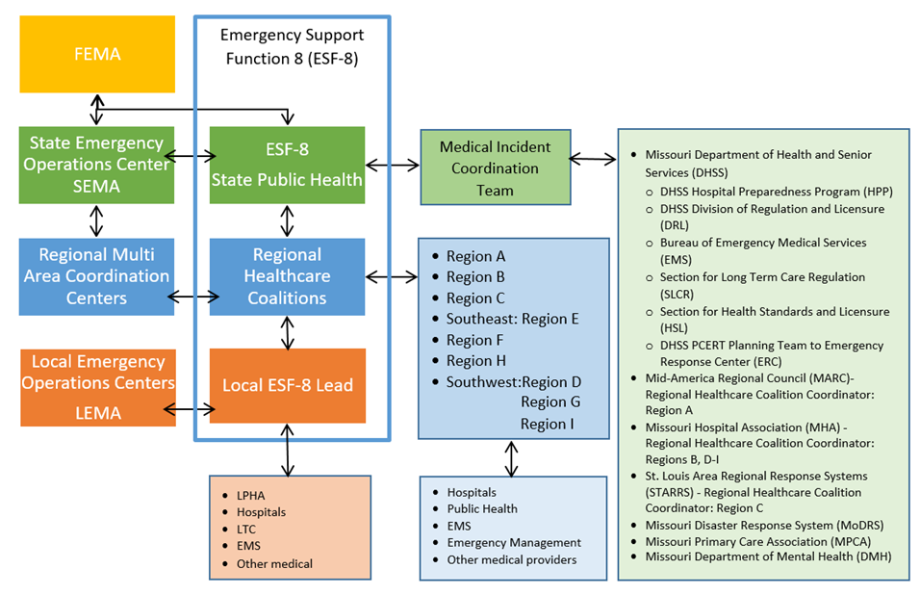

**Figure 4: Illustrates the Integration of the Various Emergency Management Entities**.

# Information Collection, Analysis, and Dissemination

Information is vital to making good decisions during a crisis. The needed information must be collected in a timely manner, analyzed and disseminated to “need to know” parties to enable them to determine their most appropriate course of action during the incident.

Information is collected and disseminated by various systems which may include:

* Healthcare coalitions through EMResource and WebEOC
* Local/regional dispatch centers
* Local emergency operations centers
* State public health Emergency Response Center/State Emergency Operations Center

EMResource provides the capability for hospital, healthcare coalition, and medical resources to provide statewide situational awareness on hospital capabilities, operational status, and deployment status for deployable resources.

Essential elements of information contain situational awareness information that is critical to the initial and ongoing response and recovery operations. The elements listed below may not apply to every event, may not be all-inclusive, and should be modified as needed and adjusted per operational period. The facility should be prepared to share this information during a disaster or emergency event with relevant partners:

* Facility operating status
* Facility structural integrity
* Status of evacuations/shelter in-place operations
* Status of critical medical services (e.g., trauma, critical care)
* Critical service/infrastructure status (e.g., electric, water, sanitation, heating, ventilation, and air conditioning)
* Bed or patient status
* Equipment/supplies/medications/vaccine status or needs
* Staffing status
* Emergency Medical Services (EMS) status
* Epidemiological, surveillance or lab data (e.g., test results, case counts, deaths)
* Point of Dispensing (POD)/mass vaccination sites data (e.g., throughput, open/set-up status, etc.)
* Other, Please Specify

# Communications

This section of the plan is used to describe the communication protocols and coordination procedures between response organizations during emergencies and disasters. It discusses the framework for delivering communications support and how the jurisdiction’s communications integrate into the regional or national disaster communications network. Details on communications response can be found in the Communications Annex.

Day to day internal communications are carried out by Insert Communications Capabilities (i.e. pagers, overhead paging, handheld radio, vocera, etc.) Back up communication means include Insert Communications Backups. Insert Critical Communications Systems (i.e. response team pagers, etc.) are considered vital to the lifesaving functions of the facility and will be considered an emergency if they fail.

External communications are carried out by Insert External Communications (i.e. phone systems, email, etc.). In the event of a failure of Insert Critical Systems, backup systems Insert Backups will be utilized. When this is not possible, the emergency plan will be placed into effect. See the Communications Appendix for more information on communication system failures.

The facility has priority telephone restoration with the local phone company in the event of a community outage.

# Patient/Resident Management in an Emergency

## Patient Scheduling, Triage/Assessment, Treatment, Transfer, and Discharge

In the event of an emergency affecting the facility, the Insert Position Title and/or Department(s)will assess staffing and Insert Facility Type capacity. Additional staff may be called upon to assist in managing the anticipated number of cases. The medical staff will immediately evaluate all current Insert Facility Type inpatients and decide who can be safely discharged or moved to lower levels of care. The Insert Position Title and/or Department(s) will facilitate patient discharges, notify the Insert Position Title and/or Department(s) of all available beds, and update EMResource as needed for facility status and bed availability. The Insert Location will serve as the holding area for discharged patients awaiting transportation from family or friends Insert Facility Type admissions and scheduling for elective procedures may be curtailed until the emergency situation has subsided.

All personnel will report to their assigned area. The Insert Position Title and/or Department(s) will take stretchers, wheelchairs and blankets to the Triage area. As the victims arrive, assigned nurses will assist physicians in triaging patients using the Insert Method (i.e. START Triage) and direct them to the appropriate treatment area with treatment orders. Victims requiring immediate life-saving procedures will be taken directly to the Insert Location (i.e. emergency room). The Insert Position Title and/or Department(s) will tag the victims as they arrive in the treatment area. See Appendix XX: Patient Care and Safety/Patient Surge for more information on the Patient Surge Plan.

## Vulnerable Populations

Vulnerable populations are patients who are pediatric, geriatric, disabled, or have serious chronic conditions or addictions. As these patients are identified in the triage process, they will be linked with needed Insert Facility Type services. For those services the Insert Facility Type cannot provide, social service personnel will assist the patient by linking them with healthcare or social service agencies that can provide the assistance the patient requires.

## Management of Behavioral Health Patients

The management of patients receiving behavioral health services will be coordinated with Insert Position Title and/or Department(s) and security as necessary. Patient medications and medical records should accompany the patient Insert How in the event they are being transferred or evacuated to another facility. Coordination should be made with the receiving facility to ensure it can adequately accommodate the patient.

## Behavioral Health Services to Patients

Prior to an emergency, the Insert Position Title and/or Department(s) will establish links with local community mental health centers and community service organizations to identify community resources that can respond to the mental health needs of patients in an emergency. Current contact information will be maintained for these organizations so patients, their families, and others can be referred to those resources if needed. The Insert Position Title and/or Department(s) will also ensure that appropriate Insert Facility Type personnel have been trained in psychological first aid or other psychosocial interventions to ensure the Insert Facility Type can provide support to patients needing such care.

During and after an emergency, the Insert Position Title and/or Department(s) will coordinate Insert Facility Type and community mental health resources to provide support for patients, family members and staff.

## Patient/Resident Tracking

Insert Facility’s Tracking Policy, if no policy in place describe below

The Emergency Department and other departments receiving patients will have a patient tracker assigned to track the patients entering and leaving the patient care areas. In the Emergency Department, the Insert Position Title and/or Department(s) will perform this task in conjunction with the triage areas and charge nurse or designee. The Insert Position Title and/or Department(s) staff will use the HICS 254 - Disaster Victim Patient Tracking Form (See HICS forms provided by located in Appendix XX), using the triage tracking number to log in patients at the point of triage. The location of these patients in the continuum of care will be logged in using this form until disposition status is determined.

In the event that the computer system is down, the registration staff will coordinate the use of the Disaster Victim Patient Tracking Form with the Insert Facility Type Patient Tracking System.

Ensure that all patient identification wristbands (or equivalent identification) must be intact on all patients.

If patients are evacuated, the HICS 260 - Patient Evacuation Tracking Form will be used. When more than two patients are being evacuated, the HICS 255 - Master Patient Evacuation Tracking Form (See HICS forms in Appendix XX) should be used to gain a master copy of all those that were evacuated. Form should include, but is not limited to: resident name, date of birth, Medicare/Medicaid number, evacuation site location, date of evacuation, arrival time at evacuation site, date of return to facility (if known), and comments/notes.

Each patient unit, in conjunction with the Insert Position Title (i.e. Patient/Resident Tracking Manager), shall designate a team member responsible for this task. The information for each patient must be completed when the receiving Insert Facility Type is contacted and a report given regarding the patient’s status. The Insert Position Title (i.e. Patient/Resident Tracking Manager) or designee shall assist the evacuating unit as necessary to assure that appropriate tracking information is completed for each nursing unit.

In addition, Insert Facility Namewill utilize third-party information such as Insert Other Patient Tracking System That May Be Used (i.e. JPaTS, American Red Cross database or fax tracking information)as appropriate to assist families in locating patients.

## Evacuation or Shelter in Place

The decision to evacuate or shelter in place will be made by the Insert Title This decision will be based on the determination of the safest course of action for the patients/residents. External factors for consideration are the nature and timing of the storm and the projected path, the status of the community infrastructure and resources, and available support. Internal factors may include the facility vulnerability, the level of patient acuity, and the status of internal resources to evacuate or support care.

Once the patients/residents are evacuated, appropriate care and treatment must continue to be delivered. Supplies, food, water, and pharmaceuticals must accompany the evacuated personnel and patients to ensure care and living needs are met.

## Transportation Resources for Evacuation

A preliminary assessment of transportation resource needs has been conducted and can be found in the Evacuation Plan: Appendix XX. The total time that is allotted for the safe evacuation should be considered when requesting transportation resources for evacuation.

## Evacuation Locations

Facilities have been identified that have agreed to serve as receivers for Insert Facility Name’s patients/residents, should they need to be evacuated. These facilities are listed in the evacuation plan. Agreements are listed in the Mutual Aid Agreement Section. Destinations will be determined based on the acuity level of the patient in relation to the receiving facilities capabilities to provide the appropriate level of care along with the operational status and distance to the evacuating facility.

## Medical Documentation

Medical records that enable continuity of care must accompany patients/residents to their evacuation destination. Insert Your Facility’s Plan/Process for Ensuring Medical Documentation Accompanies the Patient. This system will preserve patient information, protect the confidentiality of the patient information and secure and maintain the availability of records.

## Shelter in Place

If the facility administration, along with safety and public safety officials, determines that sheltering in place is the safest course of action for the patients/residents, staff, and volunteers, the command center will be activated to ensure patient care and staff needs are met. The command center will plan for and ensure care and sustenance needs are met along with ensuring a safe environment. Staff and volunteers will be housed in Insert Staff Housing Plan Locations.

## Alternate Care Sites

Alternate care sites may be activated in the event that the hospital/facility becomes unsafe and emergency shelter is needed, there is a surge of patients that can’t be managed by normal operations and an alternate care facility is determined to be the best off site care option. Should the facility determine a need to activate and operate an alternate care site, they will immediately contact their local emergency manager and the Missouri Department of Health and Senior Services, Emergency Response Center to notify them of the plans for alternate care sites and to request an 1135 waiver. A detailed alternate care site plan can be found in Appendix XX.

# Utilities

## Power

Power is a critical utility for the operations of the Insert Facility Name. Power to the facility is critical to maintain List Critical Power Dependencies (i.e. facility temperature control, lifesaving equipment such as ventilators, etc.). The Facility Command Center will be activated anytime there is more than a momentary failure of electrical power to the facility to coordinate restoration of power and ensure patient safety.

The sudden loss of normal power should cause emergency generator backup power to be initiated. The emergency generator(s) will provide power to All or Parts of the facility. Areas and functions powered by the generators include; List Areas and Functions Powered by the Generator(s) – (Must include provisions to maintain temperatures to protect patient health and safety and the safety and sanitary storage of provisions (refrigeration), emergency lighting, fire detection, extinguishing and alarm systems, sewage and waste disposal). Areas and functions that are not powered by the generators include List Areas and Functions Not Powered by the Generators.

The Insert Position Title and/or Department(s) is responsible for managing the restoration of power to the facility. If the outage is due to the power supply to the facility, they will notify the power company to report the outage and get an estimated time that the power will be restored. The Insert Position Title and/or Department(s) will notify all departments of the power failure and the status of repair. In the event a power failure happens after normal business hours, the Insert Position Title (i.e. Dispatcher) and/or Department(s)will immediately notify the Insert Position Title and/or Department(s) to report the outage.

Individual departments and units will be responsible for identifying critical power dependent functions in their area and ensuring that available power or backup means are connected to ensuring continuity of patient care and safety. Any urgent needs should be communicated to the Command Center as soon as possible.

### Generator Failures

The emergency generator is located in compliance with the Health Care Facilities Code (NFPA 99 and NFPA 110) when a new structure is built or when an existing structure or building is renovated. The generator is inspected, tested, and maintained in compliance with NFPA 99, 110, and the Life Safety Code.

In the event of a generator failure, the problem is immediately assessed by the Insert Position Title and/or Department(s), who will make needed repairs or contact the Insert Name and Contact Information of Generator Maintenance Company.

If the Insert Facility Type’s power distribution system fails and cannot be repaired in a reasonable time-period, the Insert Name of Local Emergency Management Agencyshould be notified. The Emergency Management Agency will assess if resources are available to provide assistance or if evacuation is necessary.

Insert General Plan for Limited Generator Failure and Backup Generator Provision

## Water

### Water for Drinking, Cooking, and Sanitation

Water is a critical utility for the operations of the Insert Facility Type. Water is critical for List (i.e. chiller operations, dialysis, drinking, handwashing/sanitation, toilet operations. If there is an interruption in water service, the problem will be immediately assessed by Insert Position Title and/or Department(s), who will make needed repairs or contact Insert Name and Contact Information for Water Supplierto report the outage and get an estimated time that water service will be restored. The Insert Position Title and/or Department(s) will notify all departments of the water service interruption and anticipated time of restoration. If a water service interruption happens after normal business hours, the Insert Position Title (i.e. Dispatcher)will immediately notify the Insert Position Title and/or Department(s) to report the situation. The Insert Position Titlewill determine if water use restrictions should be implemented (i.e., bathing, cooking, etc.), or if patient relocations, discharges, or transfers are necessary.

### Water Rationing

If an emergency situation is anticipated that could affect water supplies, certain measures can be initiated to ensure the Insert Facility Type has enough potable and non-potable water to supply the facility until water service is restored. The facility can stockpile bottled water for drinking and cooking. If the event allows, containers capable of holding water can be filled prior to the event including pots, buckets, and bath tubs.

If an event occurs that limits water supplies to the facility, water rationing measures may be initiated to conserve water until water supplies have been restored. Patient sanitary needs will be addressed by the use of bedside toilets or bedpans. Waste from bedside toilets or bedpans will be red-bagged and disposed of as hazardous waste. Another method is the use of cat litter in red bags. If using this method, the red bags and cat litter will be placed in toilets. When deemed necessary by Infection Control or when water service is restored, the red bags will be removed from the toilets and disposed of as biohazard waste.

Water used for bathing and cleaning may have to be restricted. Hand washing will require soap and water, if in sufficient quantity. If water is unavailable, the use of hand sanitizers will be encouraged. Fruit juices and broth, which should normally be discarded in preparing meals, could be set aside for use in preparing meals that may call for adding water. Insert Facility Policy

## Medical Gas/Vacuum Systems

### Vacuum System

In the event of a loss of the vacuum system, the Insert Position Title and/or Department(s) and Facility Administration must be notified immediately. They will determine if repairs can be made in an expeditious manner or whether portable suction equipment beyond reserve units in the Insert Facility Typemust be procured. In any event, nursing personnel in affected areas must ensure that patients with artificial airways and those in need of tracheal suction receive priority attention until the patient is relocated to an unaffected area or the primary vacuum system is restored.

In the event of a loss of medical gases, the Insert Position Title and/or Department(s) and Facility Administration must be notified immediately. The responsible individual will determine if repairs can be made in an expeditious manner or if emergency medical gas supplies must be procured.

The Insert Facility Type maintains Identify the Amount of Medical Gas Available and the Location.Additional cylinders can be procured through Insert Name and Contact Information of Supplier.

## Maintenance Activities

The following table lists other utilities critical to the comfort and care of residents and daily operations that should be addressed for maintenance.

**Maintenance Activities**

|  |  |  |  |  |
| --- | --- | --- | --- | --- |
| **System** | **Primary Personnel** | **24/7 Contact Information** | **Outside of Facility** | **24/7 Contact Information** |
| Generators/Electric | Primary Personnel | 24/7 Contact Information | Outside of Facility | 24/7 Contact Information |
| Heating, ventilation, and air conditioning | Primary Personnel | 24/7 Contact Information | Outside of Facility | 24/7 Contact Information |
| Water/Sewer Systems | Primary Personnel | 24/7 Contact Information | Outside of Facility | 24/7 Contact Information |
| Medical Gases/Vacuum Systems | Primary Personnel | 24/7 Contact Information | Outside of Facility | 24/7 Contact Information |
| Information Technology | Primary Personnel | 24/7 Contact Information | Outside of Facility | 24/7 Contact Information |
| List others that apply | Primary Personnel | 24/7 Contact Information | Outside of Facility | 24/7 Contact Information |

# Recovery

## Initiation and Recovery

The decision to enter into the recovery stage of an event is made by the Insert Position Title. In this stage, the Insert Name of Facility will undertake recovery procedures to return the Insert Facility Type to normal operations.

## Recovery Protocol

In order to efficiently recover from an event, protocols must be followed. Listed below are protocols important to recovery operations.

Recovery protocols**:**

* Prioritize health care service, delivery, and recovery objectives by organizational essential functions.
* Maintain, modify, and demobilize healthcare workforce according to the needs of the facility.
* Work with local emergency management, service providers, and contractors to ensure priority restoration and reconstruction of critical building systems.
* Maintain and replenish pre-incident levels of medical and non-medical supplies.
* Work with local, regional, and state emergency medical system providers, patient transportation providers, and non-medical transportation providers to restore pre-incident transportation capability and capacity.
* Work with local emergency management, service providers, and contractors to restore information technology and communication systems.
* Prepare after-action reports, corrective action reports, and improvement plans.

## Restoration of Services

TheInsert Position Title will coordinate the restoration of services after an emergency situation affecting the Insert Facility Type.

List Responsibilities in Restoring Services (i.e. restoration of utilities, repair or replacement of critical systems, and overseeing of facility repairs)

## Utility Restoration

Describe Procedures for Restoration of Critical Systems Not Already Identified in the Plan or Identify Where These Procedures Can Be Located.

## Staff/Patient Re-Entry

TheInsert Position Title will work with the Division of Regulation and Licensure to give approval for the return of staff and patients to the facility. The coordination of the return of staff and patients to the facility will be the responsibility of the Insert Position Title.

List Preparations and Procedures for Returning Residents after an Emergency (i.e. transport of patients back to the facility and related activities)

## Staff Debriefing

A debriefing will be conducted within Insert Number of Hours of the incident to collect lessons learned from the incident or exercise. These lessons learned will be used to revise and update the plan. The Insert Position Title will be responsible for coordinating the debriefing.

## After-Action Report/Improvement Plan

After any real incident or exercise where the emergency operations plan is activated, an after-action report and an improvement plan will be developed. The purpose of the after-action report is to document the overall performance of the organization during the exercise or real event. It will contain a summary of the scenario or events, staff actions, strengths, issues, opportunities for improvement, and best practices.

The purpose of the after-action report/improvement plan is to ensure issues and opportunities for improvement are adequately addressed to improve response capabilities to future events. The improvement plan will include a list of issues to be addressed, tasks that will be performed to address them, individuals responsible for completing the tasks, and a timeline for completion.

The Insert Position Title will be responsible for coordinating the development of the after-action report and improvement plan and will ensure identified improvements are completed within the targeted timeframes.

# Administration, Finance, and Logistics

## Logistics

### Resources and Assets

**Acquiring and Replenishing Food, Water, Medications and Supplies**

The amounts and locations of food, water, pharmaceuticals, and medical and non-medical supplies are evaluated during emergency plan activation to determine how many hours the facility can sustain itself before needing re-supply. This gives the facility a par value and aids in the projection of sustainability before terminating services or evacuating if needed supplies are unable to reach the facility.

Supplying the Insert Facility Type in an emergency will be initially satisfied by pulling from local resources. As replenishment becomes necessary, resources will be requested from vendors. A list containing the names and contact information of the vendors that deliver and/or manufacture supplies and provide critical services can be found in Appendix XX: Communications Plan/Contact Lists.

If the Insert Facility Type is unable to acquire sufficient resources through outside vendors and pre-positioned arrangements to meet the healthcare needs of the community, the Insert Position Title will communicate this need to the Insert Name of Local Emergency Management Agency to help locate resources and replenishments. Potential sources include other healthcare facilities through mutual aid agreements or regional or state medical supply caches requested through the local emergency management agency. If sufficient supplies cannot be acquired, the local emergency management agency will also provide assistance coordinating the transfer of patients to other facilities upon request.

**Sharing Resources with Other Healthcare Organizations**

**Include procedure for sharing or borrowing supplies within the** Insert Facility Type **network, if applicable**.

If the healthcare organizations sharing the resources are within Insert Name of Jurisdiction, a Resource Accounting Record form (HICS Form 257) should be used to document the borrowed or loaned products. See HICS forms in Appendix XX. The equipment should then be returned after use. Any consumable supplies that are used should be billed via invoice and paid by the organization using the supplies. Any unused consumables should be returned.

**Include other procedures, if applicable.**

If the items shared or borrowed come from outside Insert Name of Jurisdiction, the request should be coordinated through the Insert Name of Emergency Management Agency.The facility should document the final location of the supplies and the quantity and type of items transported. The need must be demonstrated to exceed that of the local jurisdiction prior to disbursement of supplies or equipment.

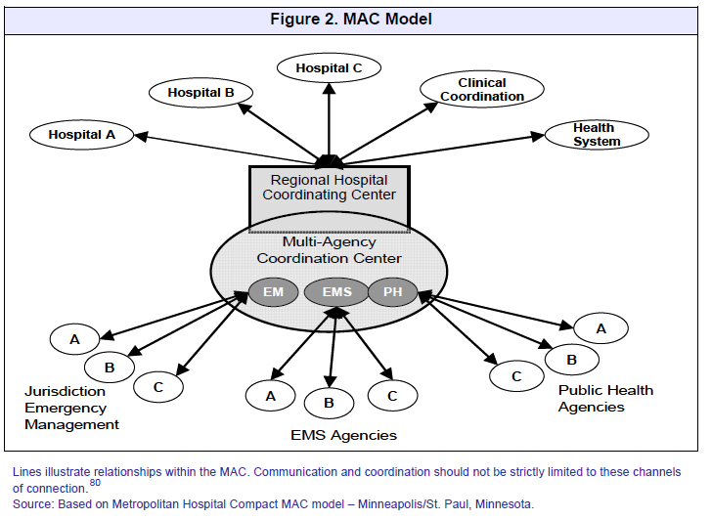

**Include other procedures, if applicable.**

**Monitoring Quantities of Resources and Assets**

The Insert Position Title is responsible for monitoring quantities of assets and resources during emergency plan activation. A Resource Accounting Record form (HICS Form 257) should be used when resources and assets are tracked during an emergency. See HICS forms in Appendix XX.

List Other Inventory Tracking Systems, if applicable

**Resource Sustainability**

Establishing the sustainability of resources is crucial to determining if services can be rendered during a disaster, based on the facility’s assessment of their hazard vulnerabilities. Resource inventory is currently maintained to provide for approximately Insert Number of Hours/Days. If this cannot be sustained through current inventory, agreements are in place with suppliers and vendors for the remaining days. If supplies cannot be obtained, policies and procedures are in place in the event the facility may need to evacuate or temporarily close.

Agreements can be found in Appendix XX: Mutual Aid Agreements/Memorandum of Understanding.

### Management of Staff

### Assignment of Staff

Following a disaster, facility personnel must be accounted for. Their location and status should be ensured by unit supervisors, along with the status and location of all patients. They will be tracked during the emergency plan activation to ensure safety and accountability.

Facility personnel may not be assigned to their regular duties or their normal supervisor during emergency plan activation. They may be asked to perform various jobs that are vital to the operation but may not be their normal day to day duties. The Labor Pool is the designated reporting location for reassignment of available staff and volunteers and will be located at Insert Reporting Location**.**

The Insert Position Title will delegate assignments based on communication with the Insert Facility Type Command Center. Staff will be assigned as needed and provided information outlining their job responsibilities and who they report to.

Insert Facility Policy/Reference

### Managing Staff Support Needs

In some circumstances, it may be necessary to provide food, housing, and/or transportation for staff that might not otherwise be able to perform their critical functions for the Insert Facility Type**.** These staff support functions will be coordinated through the Insert Position Title.

Disasters can create considerable stress for those providing medical care. The Insert Position Title will coordinate the provision of mental health support including incident stress debriefings for staff with organizations listed in Appendix XX.

## Volunteer Management

Volunteers may be needed during a large scale disaster. Volunteers that are utilized in a professional capacity must be credentialed, or to have their licensure verified, prior to commencing medical duties. The volunteer must be accompanied by like facility staff for a period of time to ensure they are competent.

A Volunteer contact list can be found in Appendix A: Communications, Attachment 2.3.

Volunteers may also be obtained from the state medical volunteer registry, Show Me Response. Hospitals may access staff through the Missouri Hospital Mutual Aid Agreement.

# Plan Development and Maintenance

## Plan Review

The EOP will be reviewed and updated annually incorporating the latest NIMS elements, lessons learned during actual and exercise plan activations, changes in the hazard vulnerability assessment, changes in emergency equipment, changes in external agency participation, etc.

Plan review should also consider changes in contact information, new communications with the local Emergency Management Agency, review of evacuation routes and alternate care sites, and staff and departmental assignments. The review will be conducted byInsert Position Title or Group.Plan updates will be the responsibility ofInsert Position Title.

## Training Program

A training program has been created to ensure adequate training of staff and others, on the emergency plan and its associated components. Training on the Emergency Plan will be provided to all new and existing staff, individuals providing services under arrangement, and volunteers, consistent with their expected roles. In addition, emergency preparedness training will be provided at least annually. Documentation of this training will be kept and staff will be able to demonstrate knowledge of these emergency procedures, as appropriate to their role in the plan.

## Exercise Program

The Insert Name of Facility will test its plan and operational readiness at least twice per year, utilizing high hazard scenarios per the Hazard Vulnerability Analysis. The Insert Facility Type will participate in a community full scale exercise at least annually; if such exercise opportunity is accessible. If not accessible, the Insert Facility Type will conduct a full scale exercise. Also the Insert Facility Type will conduct one additional exercise of any type at least annually. Appendix XX contains information specific to this exercise program.

Resources for connecting with a community exercise may be available through your regional healthcare coalition (page 59) or your Local Emergency Planning Council (LEPC) (Appendix XX).

All exercises and real events will be documented using the HSEEP AAR/IP Template found in Appendix X. This report shall be completed within 60 days of the exercise or real event. The Insert Position Title will be responsible for coordinating the exercises, after action reporting, and improvement planning. The AAR/IP will be incorporated into the emergency plan as soon as it is feasible. All improvement items will be tracked using Appendix XX**,** Corrective Action Plan Tracking Matrix.

All exercises will incorporate elements of the National Incident Management System, Hospital or Nursing Home Incident Command System, and are Homeland Security Exercise and Evaluation Program compliant.

Future exercises should be planned and conducted to reflect anticipated hazards, incorporating gaps and improvement action items identified during previous exercises and real events.

## Finance

Expenditures should be tracked from the beginning of the disaster to include personnel time, supplies, equipment use (i.e. snow clearing equipment), rental of equipment, etc. The Finance Section should put processes in place to ensure the needed tracking occurs. Forms that may be used for expense tracking include HICS 252: Section Personnel Time Sheet, HICS 253: Volunteer Registration, HICS 256: Procurement Summary Report, and HICS 257: Resource Accounting Record.

# Authorities and References

The facility is licensed by Insert Licensing and/or Accreditation Body**.** This plan shall be developed and maintained to meet emergency preparedness regulatory requirements.

Insert Title and Date of Local City and/or County Emergency Operations Plan

Insert Titles of Other Organizational Plans or Policies That Have a Connection to the Emergency Operations Plan

**Missouri State Emergency Management Agency (SEMA)**

<http://sema.dps.mo.gov>

**Missouri Registry of Healthcare Professionals**

<https://www.showmeresponse.org/>

**State Surveyor Guide**

<https://www.cms.gov/Regulations-and-Guidance/Guidance/Manuals/downloads/som107ap_pp_guidelines_ltcf.pdf>

**Missouri Revised Statutes - Chapter 198 Nursing Homes and Facilities**

<http://www.moga.mo.gov/mostatutes/chapters/chapText198.html>

**Department of Health and Senior Services - Division 30/Division of Regulation and Licensure, Chapter 85 - Intermediate Care and Skilled Nursing Facility**

<http://s1.sos.mo.gov/cmsimages/adrules/csr/current/19csr/19c30-85.pdf>

42 CFR Ch. IV, Part 483, Requirements for States and Long Term Care Facilities, 483.75, Administration: (m) Disaster and Emergency Preparedness.

42 CFR Ch. IV, Part 483, Requirements for States and Long Term Care Facilities, Subpart I Conditions of Participation for Intermediate Care Facilities for the Mentally Retarded, Sec. 483.470, Condition of participation: Physical environment; (h) Disaster and Emergency Preparedness.

19 CSR Chapters 85, 86 and 90, Regulations for Skilled Nursing Facilities, Intermediate Care Facilities, Residential Care Facilities, Assisted Living Facilities, and Adult Day Care.

**National Incident Management System (NIMS)**

Federal Emergency Management Agency (FEMA)

<http://www.fema.gov/emergency/nims/>

**Incident Command System (ICS)** FEMA

<https://www.fema.gov/incident-command-system-resources>

**The Joint Commission**

[www.jointcommission.org](http://www.jointcommission.org)

**Strategic National Stockpile**

Centers for Disease Control and Prevention

<http://www.bt.cdc.gov/stockpile/index.asp>

**Centers for Medicare & Medicaid Services (CMS)**

<http://www.cms.gov>

**Disaster Resiliency and NFPA Codes and Standards**

Refer to the National Fire Protection Association (NFPA) Standards in NFPA 101 Life Safety Code, and NFPA 1600, Disaster/Emergency Management and Business Continuity Programs

**CDC Emergency Water Supply Planning Guide Table 6-4.1**

<http://www.cdc.gov/healthywater/pdf/emergency/emergency-water-supply-planning-guide.pdf>

<http://www.phe.gov/Preparedness/planning/hpp/reports/Documents/hc-coop2-recovery.pdf>

<http://www.phe.gov/Preparedness/planning/mscc/healthcarecoalition/chapter6/Pages/implementation.aspx>

# Glossary

* **Activation** - When all or a portion of the plan has been put into motion.
* **After-Action Report (AAR)** - A report that includes observations of an exercise or real event and that makes recommendations for improvements. The purpose of the after-action report is to document the overall performance of the organization during the exercise or real event. It will contain a summary of the scenario or events, staff actions, strengths, issues, opportunities for improvement, and best practices.
* **Communications Redundancy** - A communications system wherein alternative modes of communication are present in case a component fails.
* **Continuity of Operations (COOP) Plan (Business Continuity)** - Planning designed to facilitate the continuance of mission essential functions and the protection of vital information in the event that the organization is faced with a situation that could disrupt operations.
* **Corrective Action Plan (CAP)** - The concrete, actionable steps outlined in the Improvement Plan (IP) that are intended to resolve preparedness gaps and shortcomings experienced in exercises or real-world events.
* **Decontamination** - The process of making safe by eliminating poisonous or otherwise harmful substances, such as noxious chemicals or radioactive material.
* **Delegations of Authority** - Specifies who is authorized to make decisions or act on behalf of facility leadership and personnel if they are away or unavailable during an emergency.
* **Devolution Site** - Alternate site designated for Continuity of Operations if original site is compromised.
* **Emergency Operations Center (EOC)** - A specially equipped facility from which emergency leaders exercise direction and control, and coordinate necessary resources in an emergency situation.
* **Hazard Vulnerability Analysis (HVA)** - Identifies possible hazards, including their probability, severity, frequency, magnitude, and locations/areas affected.
* **Health Alert Network (HAN)** - A nationwide program to establish the communications, information, distance-learning, and organizational infrastructure used to defend against health threats, including the possibility of bioterrorism.
* **Health Care Coalitions (HCCs) –** Groups of individual health care and response organizations (e.g., hospitals, EMS, emergency management organizations, public health agencies, etc.) in a defined geographic location – play a critical role in developing health care delivery system preparedness and response capabilities. HCCs serve as multiagency coordination groups that support and integrate with ESF-8 activities in the context of incident command system (ICS) responsibilities. HCCs coordinate activities among health care organizations and other stakeholders in their communities.
* **Health Insurance Portability and Accountability Act of 1996 (HIPAA)** - U.S. government legislation that ensures a person’s right to buy health insurance after losing a job, establishes standards for electronic medical records, and protects the privacy of a patient’s health information.
* **Homeland Security Exercise and Evaluation Program (HSEEP)** - Developed by the Department of Homeland Security (DHS) as a threat and performance-based exercise program that provides doctrine and policy for planning, conducting, and evaluating exercises. HSEEP was developed to enhance and assess terrorism prevention, response, and recovery capabilities at the federal, state, and local levels. HSEEP training courses are free and available online.
* **Human-Caused Events** - An event that is a result of human intent, negligence, or error, or involving a failure of a man-made system. Includes terrorism, criminal events, biological events, hazardous material and chemical spills, extended power outages, fires, or any event for which a human is responsible.
* **Improvement Plan (IP)** - Identifies specific corrective actions, assigns to responsible parties, and establishes targets for completion.
* **Incident Command System (ICS)** - A standardized, on-scene, all-hazards incident management approach that allows for the integration of facilities, equipment, personnel, procedures, and communications operating within a common organizational structure; enables a coordinated response among various jurisdictions and functional agencies, both public and private; and establishes common processes for planning and managing resources.
* **Isolation** - The separation of an ill patient from others to prevent the spread of an infection or to protect the patient from irritating or infectious environmental factors.
* **Key Personnel** - Personnel designated by their department, organization, or agency as critical to the resumption of mission-essential functions and services.
* **Long Term Care Facility** - A facility that provides rehabilitative, restorative, and/or ongoing skilled nursing care to patients and residents in need of assistance with activities of daily living. Long term care facilities include nursing homes, rehabilitation facilities, inpatient behavioral health facilities, and long-term acute care hospitals.
* **Mission Essential Functions (Essential Functions)** - Activities, processes, or functions that could not be interrupted or unavailable for several days without significantly jeopardizing the operation of the department, organization, or agency.
* **Mitigation** - The stage of emergency management where activities are conducted that eliminate or reduce the possibility of a disaster occurring. For healthcare operations, this might include the installation of generators for backup power, the installation of hurricane shutters, or the raising of electrical panels to protect from possible flood damage.
* **Mutual Aid Agreements (MAA)** - Arrangements made between governments or organizations, either public or private, for reciprocal aid and assistance during emergency situations where the resources of a single jurisdiction or organization are insufficient or inappropriate for the tasks that must be performed to control the situation. These are also referred to as inter-local agreements or Memorandum of Understanding (MOU).
* **National Incident Management System (NIMS)** - A systematic, proactive approach to guide departments and agencies at all levels of government, nongovernmental organizations, and the private sector to work seamlessly to prevent, protect against, respond to, recover from, and mitigate the effects of incidents, regardless of cause, size, location, or complexity, in order to reduce the loss of life and property and harm to the environment.
* **Natural Disasters** - The effect of a natural hazard that affects the environment and leads to financial, environmental, and/or human losses.Includes severe weather events such as hurricanes, tropical storms, thunderstorms, snow and ice storms, mudslides, floods, and wildfire events.
* **Orders of Succession** -Ensures leadership is maintained throughout the facility during an event when key personnel are unavailable.
* **Personal Protective Equipment (PPE)** - Specialized clothing or equipment worn by an employee for protection against infectious materials.
* **Preparedness** -The stage of emergency management where activities are conducted to develop the response capabilities needed in the event an emergency occurs. These activities may include developing emergency operations plans and procedures, conducting training for personnel in those procedures, and conducting exercises with staff to ensure they are capable of implementing response procedures when necessary.
* **Public Health** - The science and practice of protecting and improving the health of a community, as by preventive medicine, health education, control of communicable diseases, application of sanitary measures, and monitoring of environmental hazards.
* **Public Information** - Information that is disseminated to the public via the news media before, during, and/or after an emergency or disaster.
* **Recovery** - The stage of emergency management that focuses on restoring operations to a normal or improved state of affairs. This stage occurs after the stabilization and recovery of essential functions. Examples of recovery activities might include the restoration of non-vital functions, replacement of damaged equipment, and facility repairs.
* **Response** - The stage of emergency management that includes those actions that are taken when a disruption or emergency occurs. It encompasses the activities that address the short-term, direct effects of an incident. Response activities in the healthcare setting can include activating emergency plans, triaging, and treating patients that have been affected by an incident.
* **Show-Me Response** - A secure registration system and database for health professional volunteers willing to respond to public health emergencies.
* **Standard Operating Guidelines (SOG)** - A set of approved methods for accomplishing a task or set of tasks. SOGs are typically prepared at the department or agency level. They may also be referred to as Standard Operating Procedures (SOPs).
* **Strategic National Stockpile (SNS)** - A federal resource to provide medicine and medical supplies to protect the public in the event of a public health emergency as a result of an act of terrorism or a large scale natural or human-caused disaster that is so severe local and state resources are inadequate or become overwhelmed.
* **Vital Records, Files and Databases** - Records, files, documents, or databases, which if damaged or destroyed, would cause considerable inconvenience and/or require replacement or re-creation at considerable expense. For legal, regulatory, or operational reasons, these records cannot be irretrievably lost or damaged without materially impairing the organization's ability to conduct business.
* **Vulnerable Populations** - Vulnerable populations are patients who are pediatric, geriatric, disabled, or have serious chronic conditions or addictions.

# Acronyms

* **AAR** After-Action Report
* **AHRQ** Agency for Healthcare Research and Quality
* **CAP** Corrective Action Plan
* **CDC** Centers for Disease Control and Prevention
* **CMS** Centers for Medicare and Medicaid Services
* **COOP** Continuity of Operations Plan
* **DHS** Department of Homeland Security
* **EMS** Emergency Medical Services
* **EOC** Emergency Operations Center
* **EOP** Emergency Operations Plan
* **EPA** Environmental Protection Agency
* **ERC** Emergency Response Center
* **ESAR-VHP** Emergency System for Advance Registration of Volunteer Health Professionals
* **ESF** Emergency Support Function
* **FBI** Federal Bureau of Investigation
* **FDA** Food and Drug Administration
* **FEMA** Federal Emergency Management Agency
* **HAN** Health Alert Network
* **HICS** Hospital Incident Command System
* **HIPAA** Health Insurance Portability and Accountability Act
* **HPP/WMD** Hospital Preparedness Program/Weapons of Mass Destruction
* **HSEEP** Homeland Security Exercise and Evaluation Program
* **HVA** Hazard and Vulnerability Analysis
* **HVAC** Heating, Ventilation and Air Conditioning
* **IC** Incident Command
* **ICS** Incident Command System
* **IP** Improvement Plan
* **IS** Independent Study
* **JAS** Job Action Sheets
* **JIC** Joint Information Center
* **JIS** Joint Information System
* **MAA** Mutual Aid Agreement
* **MOU** Memorandum of Understanding
* **NFPA** National Fire Protection Association
* **NIMS** National Incident Management System
* **NOAA** National Oceanic and Atmospheric Administration
* **NWS** National Weather Service
* **OEPR** Office of Emergency Planning and Response
* **POC** Point of Contact
* **POD** Point of Distribution
* **PPE** Personal Protective Equipment
* **SNS** Strategic National Stockpile
* **SOG** Standard Operating Guidelines
* **SOP** Standard Operating Procedures