Smartphone Training Guidelines

Camera settings
For your camera settings, it’s recommended you select: 720 HD, 30 FPS

Alternatively, you can go with:
- 4K/1080 HD – this will provide more options with what you can do with the video, but will use a lot of phone storage
- 24 FPS – will allow for a cinematic look and feel
- 60 FPS – mostly used if you plan to use slow motion when you edit

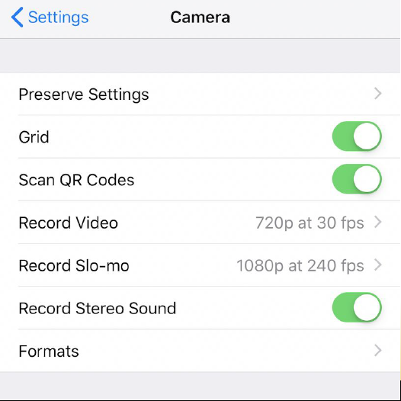

Landscape vs. portrait
There is a time and function for either of these as shown below. However, never use both for a single video. Instead, pick one or the other.

Landscape (horizontal) is used for:
- YouTube
- Facebook, Twitter
- Big screen

Portrait (vertical) is used for:
- Snapchat
- Instagram

Keys to professional video
- Stability
  - Eliminate or minimize shakiness
  - Use a tripod
  - If no tripod, use your surroundings
    - Tabletop or ground
    - Trees/walls
    - Tuck elbows, hold camera closer to body
- Lighting
  - Light source (sun, windows, etc.) ALWAYS at your back
  - Interview subject should FACE the light
  - If indoors, try to move subject underlights
  - NEVER shoot into the light
  - Signs of poor lighting technique? “Light halo” in video, subject is darker than background, lack of crispness in video

- Sound
  - Get CLOSE – an arm’s length away
  - Account for “ambient” sound: construction, children playing, traffic noise
  - Use wireless ear plugs
  - Indoors: lights that give off a “hum”, vacuum cleaners in the background, people talking

Panning and zooming
- NEVER zoom with your phone camera
- Loses resolution and quality
- “Move with your feet” (get closer)
- Pan SLOWLY and STEADILY
- Pick a starting and ending point
- “Short distance” pans
- Avoid quick, sweeping pans

Framing
- Get close enough to maximize the experience
- Faces and fronts, not butts and backs
- Sequence shots: close, medium and wide
- Match action
- Shoot lots and lots of footage, then shoot MORE

